Grade 7 Accelerated · Unit 3 · Lesson 2  Quotient Laws of Exponents  Question Bank 3.02 | Name______________________  Date______________________  Period____________________

Show your work. Circle your final answer.
For questions 1 through 3, show the quotient of powers law, then evaluate.
1. 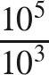

2. 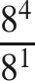

3. 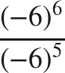

4. When dividing two powers that have the same nonzero base, keep the base and ______ the exponents.

For questions 5 and 6, apply the power of a quotient law. Do not simplify the fraction.
5. 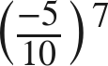

6. 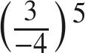

The zero exponent.
7. Fill in the missing value in the pattern: 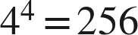, 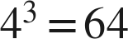, , 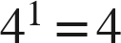, 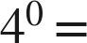 ____

8. Evaluate  and explain in one sentence why your answer is not 0.

For questions 9 through 11, rewrite the expression using a law of exponents, name the law, then evaluate.
9. 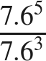

10. 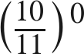

11. 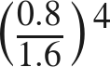

Working backwards.
12. Find the value of that makes each statement true.
a. 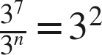

b. 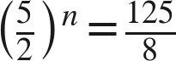

c. 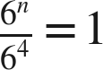

13. Which expression is equivalent to 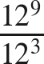 ?
○ A. 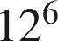
○ B. 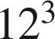
○ C. 
○ D. 

14. Select ALL of the expressions whose value is 1.
□ A. 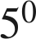
□ B. 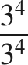
□ C. 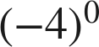
□ D. 
□ E. 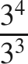
□ F. 